Topic: Parts of a Computer and the Computer System

When I am done this lesson, I will know:
- The parts of a computer system
- The basic parts of a computer (hardware)
- Common peripheral devices used with computers
- How to turn a computer on and off

Pre and Post Self-Assessment
 | Pre | Pre | Post | Post
 | Yes, I know this | No, I want to learn this | Yes, I know this | I still need more practice to learn this
I know the parts of a computer system.
I know what the basic parts of a computer are.
I know some common peripheral devices used with computers.
I know how to turn a computer on and off.

New Words and Terms

Computer Case
Monitor
Keyboard
Processor
Mouse
Trackpad
Printer
Scanner
Speaker
Webcam
Microphone
Headset
Power button
Shut down

What is a computer system?
A computer system has three main parts:
- hardware,
- software, and
- people.
In this section you will learn more about the parts of the computer.

Parts of a computer

Review | Hardware is the equipment. It is the physical parts. It includes the parts you can see and some parts that you can’t see. Hardware includes the processor, memory, storage, communication ports and peripheral devices. Peripheral devices are connected to the computer. Some examples are the display, the keyboard, a mouse, speakers, or a printer. The processor is what makes the computer work. It is like the “brains” of the computer.

The hardware includes many different parts.
The monitor, processor, keyboard and mouse are the main parts of the computer you need to know. Desktops and laptops have all of these parts. In a desktop the parts are separate whereas in a laptop, most of the parts are combined into one device. You can add a mouse to a laptop or use the trackpad which is part of the device. The processor, keyboard and trackpad are all part of the bottom of the laptop.

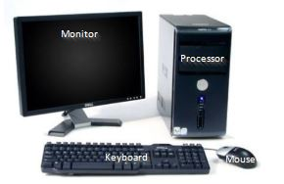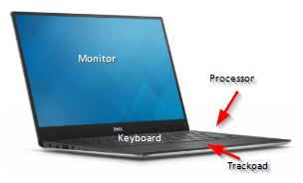

Parts of a Computer (Hardware)

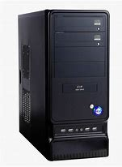 | Computer Case  This is the cabinet that contains most of the components of the computer. It is sometimes called a tower. The Central Processing Unit or CPU is in the case. The CPU is the “brains” of the computer.
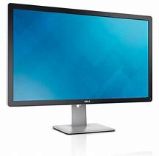 | Monitor  This is the device that displays or shows you the information from the computer. It is an output device that displays information in pictorial form.
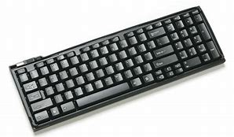 | Keyboard  This is the panel of keys that you use to operate or tell the computer what to do. It allows you to input information into the computer.
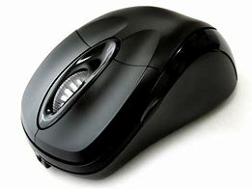 | Mouse  This is a hand-held or hand operated pointing device that helps you input information into a computer.

Other Peripheral Devices

A peripheral device is an input or output device that allows you to operate a computer. The monitor, keyboard and mouse are all peripheral devices. Other peripheral devices are described below.
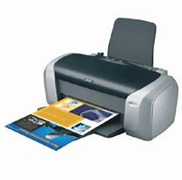 | Printer  A printer takes information generated by a computer (graphics and text) and transfers it on to paper. There are many different types of printers.
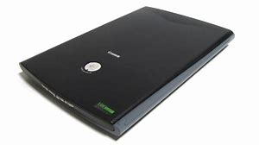 | Scanner  A scanner can take a picture of a physical item (e.g. a piece of paper with words and pictures on it) and change it into a digital format so it can be stored or used on a computer. Many printers have scanners built into them.
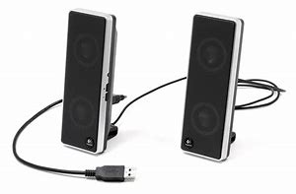 | Speakers  Speakers produce sound generated when the computer is being used. Most computers have built in speakers.
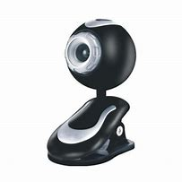 | Webcam  A webcam is a video camera that inputs to a computer connected to the Internet. It allows other users to see you when you are connected. Most laptops have webcams-built in.
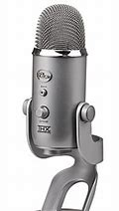 | Microphone  A microphone allows you to speak to the computer and transmit your voice or sounds over the Internet or record them. Most laptops have a microphone-built in.
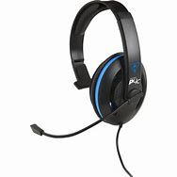 | Headset  A headset is a set of headphones that usually also has a microphone built in. It allows you to connect to a computer and speak and listen while keeping your hands free to type or use the mouse.

 | Watch this to learn more about the parts of a desktop computer.  Source: GCFGlobal.org | https://edu.gcfglobal.org/en/computerbasics/basic-parts-of-a-computer/1/

 | Watch this to learn more about a laptop computer.  Source: GCFGlobal.org | https://edu.gcfglobal.org/en/computerbasics/laptop-computers/1/

Turning the Computer On

If you are using a desktop computer, you need to turn on the processor and the monitor using the power buttons. If you are using a laptop computer, it will only have one power button.
Power buttons come in all shapes and sizes. They will be in different locations on different devices. However, a power button on computer will have this symbol on it.
 | Power button symbol

Other examples of what a power button might look like:
 | 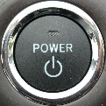 | 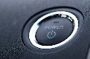 |  | 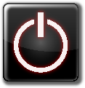 | 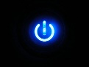 |  | 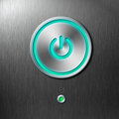 |  | 
For users who are blind or have extremely low vision, a bump dot can make power buttons more accessible.
How can I tell if the computer is on? The button will usually be lit up and will turn white, green or blue if it is on. You can also tell if a computer is on by listening for activity from the processor, fans, or drives working. If you can not hear anything, try feeling for vents for fans, as they’re usually moving air.

“Waking” the computer up

Computers are often set to go to “sleep” if no one is using them for a period of time to help conserve energy. Requiring you to logon is a safety feature for computers. When they go to sleep, they usually log off. Moving the mouse around a bit or touching the trackpad may “wake” the computer up. Sometimes you need to push the power button once to wake the computer up.

Turning the computer off

You do not use the power button to turn off the computer. You turn off the computer by clicking on the Start Button on the lower left had corner of the computer.
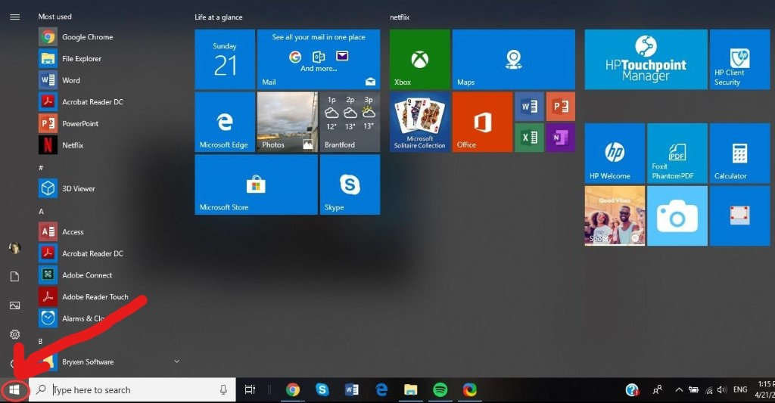
After you click on the Start Button:
- Click on POWER
- Click on SHUT DOWN

Screen reader users can access the power options from the start menu, or do the following. Press the Windows Key + M or D to go to the desktop, press Alt + F4 to bring up shutdown options, and use the arrow keys to move through the options, followed by enter to activate the focused option.
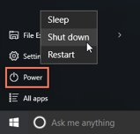

Try this/Practice

- Turn on the computer.
- Turn off the computer.

Ontario Adult Literacy Curriculum Framework Connection
Competency | Task Groups(s)
Find and Use Information | - Read Continuous Text  - Interpret Documents  - Extract Information from films, broadcasts and presentations
Communicate Ideas and Information | - Interact with Others  - Complete and Create Documents
Use Digital Technology | - n/a

